Pizza-Out Documentation
- KPIs
  - Total Revenue Generated
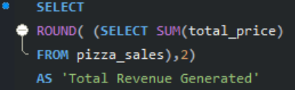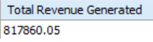
  - Average Order Value
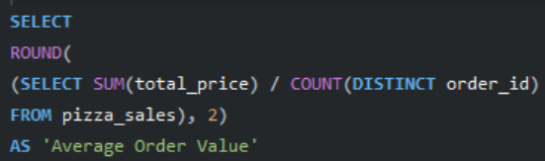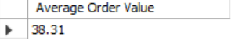
  - Total Pizzas Sold
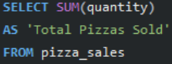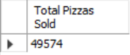
  - Total Orders Placed
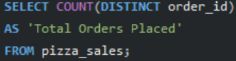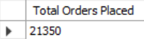
  - Average Pizzas per Order
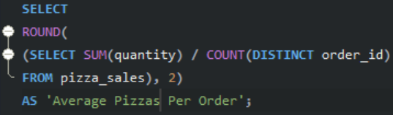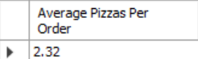

- Daily Trend
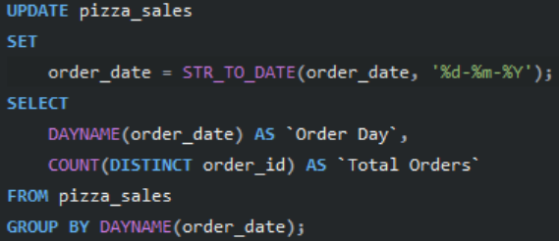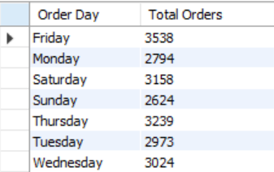
The dataset’s date was not formatted in a way that MySQL Server can interpret. It was in DDMMYYYY as opposed to YYYYMMDD. Hence the update function.
- Hourly Trend
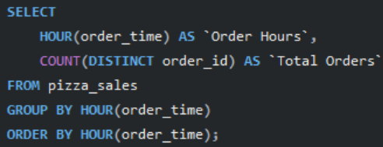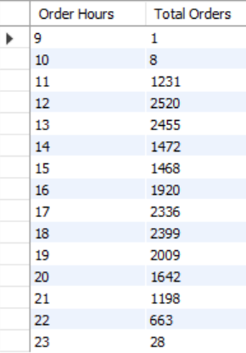
- Percentage of Sales by Pizza Category
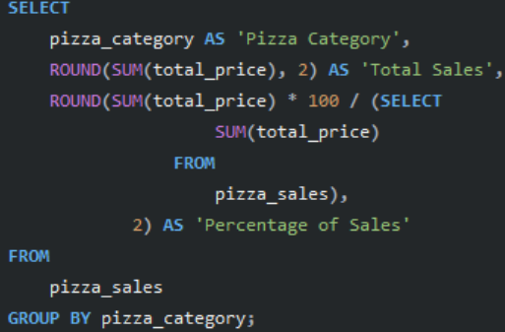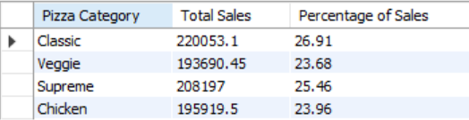
- Percentage of Sales by Pizza Size
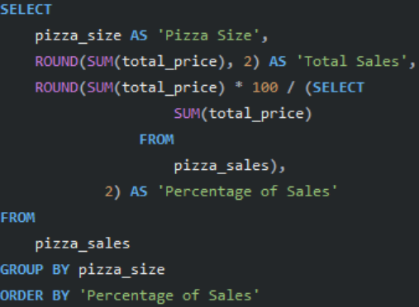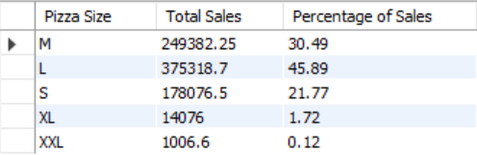
- Total Pizzas Sold by Pizza Category
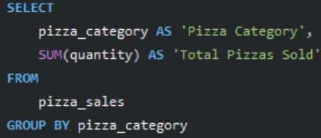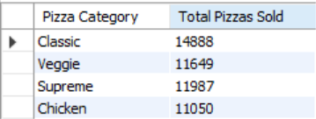
- 5 Best Sellers by Total Pizzas Sold
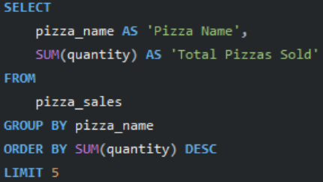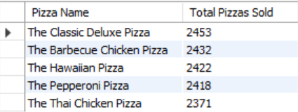
- 5 Worst Sellers by Total Pizzas Sold
